Full Stack Development with MERN
1. Introduction
• Project Title: Order On The Go: Your On-Demand Food Ordering Solution
• Team Members: Lakshmi Durga Devika Mudunuri, Settibathula Jyothi, Ramya Seelam, S N S Viswanadha Koushik Palagummi
2. Project Overview
Purpose:
The project aims to provide a seamless, user-friendly food ordering solution that caters to customers’ needs during both conventional and unconventional hours. It bridges the gap between hungry users and restaurants by offering convenience, transparency, and efficiency.
Features:
- User registration/login with multiple options (form, Gmail).
- Comprehensive product catalog with descriptions, reviews, promotions.
- Cart management (add, update, remove items).
- Secure checkout with multiple payment methods.
- Order confirmation and real-time notifications.
- Restaurant dashboard for product and order management.
3. Architecture
• Frontend: Built with React.js, HTML, CSS, and JavaScript. Provides a responsive UI for browsing menus, managing cart, placing orders, and accessing the admin dashboard.
• Backend: Developed using Node.js and Express.js. Exposes RESTful APIs for authentication, product browsing, cart operations, order placement, and admin management. Integrates with external APIs (Stripe/Razorpay, Firebase, Google Maps).
• Database: MongoDB Atlas (NoSQL). Collections include Users, Restaurants, Products, Carts, and Orders. Relationships: User → Cart → Products, User → Orders → Restaurants.
4. Setup Instructions
• Prerequisites: Node.js, MongoDB Atlas account, Git, npm/yarn.
• Installation:
- Clone repository: git clone <repo_url>
- Navigate to client and server directories.
- Install dependencies: npm install
- Configure environment variables (.env) for DB connection, API keys.
5. Folder Structure
• Client (Frontend):
- /src/components → UI components (Login, Cart, ProductList).
- /src/pages → Page views (Home, Checkout, Admin).
- /src/services → API calls.
• Server (Backend):
- /routes → API endpoints (users, products, orders).
- /models → MongoDB schemas (User, Product, Order).
- /controllers → Business logic.
- /config → DB connection, environment setup.
6. Running the Application
• Frontend:
cd client
npm start
• Backend:
cd server
npm start
7. API Documentation
• User APIs:
- POST /api/register → Register new user.
- POST /api/login → Authenticate user.
• Product APIs:
- GET /api/products → Fetch product catalog.
- POST /api/products → Add product (admin).
• Cart APIs:
- POST /api/cart → Add item to cart.
- GET /api/cart/:userId → View cart.
• Order APIs:
- POST /api/orders → Place order.
- GET /api/orders/:userId → View user orders.
8. Authentication
• Method: JWT (JSON Web Tokens).
• Process:
- User logs in → backend generates token.
- Token stored in client (localStorage).
- Token verified on each API request.
• Authorization: Role-based (RBA-(User vs Admin)).
9. User Interface

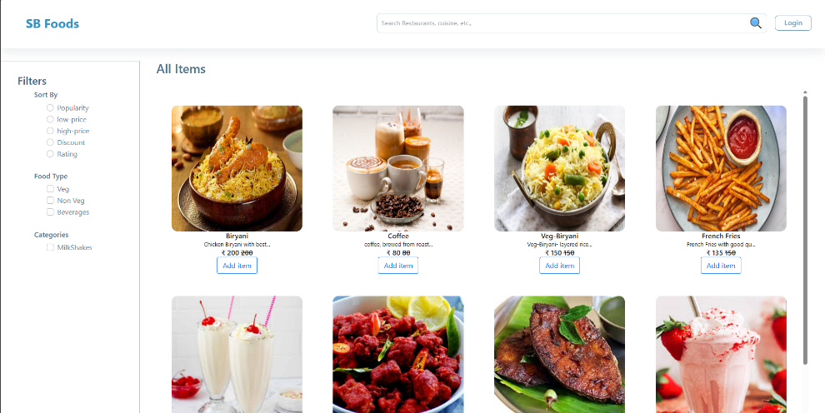

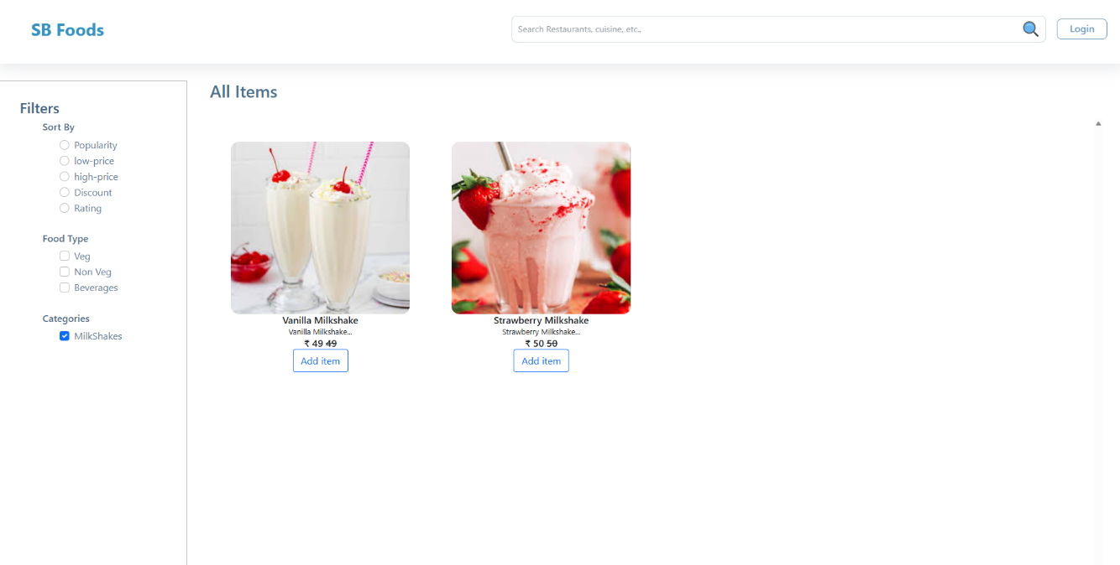
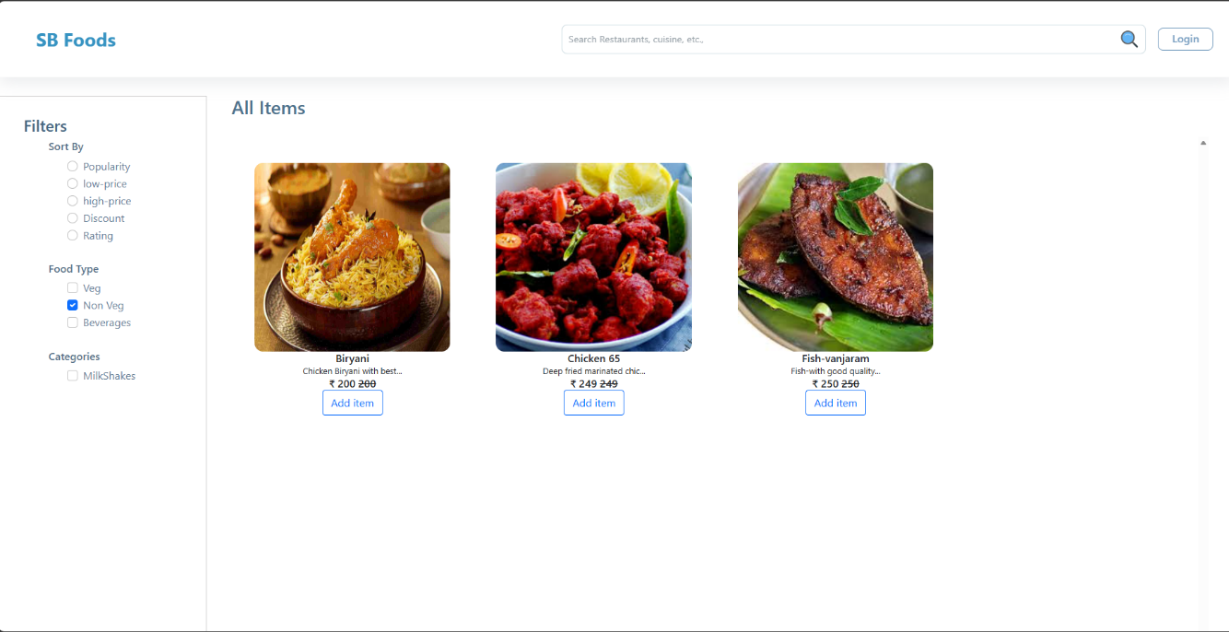
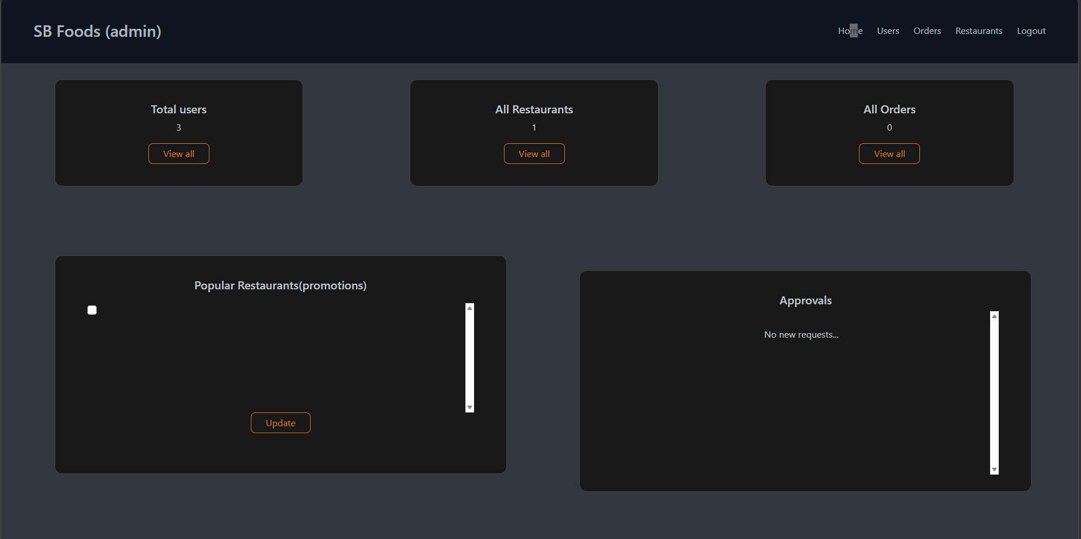
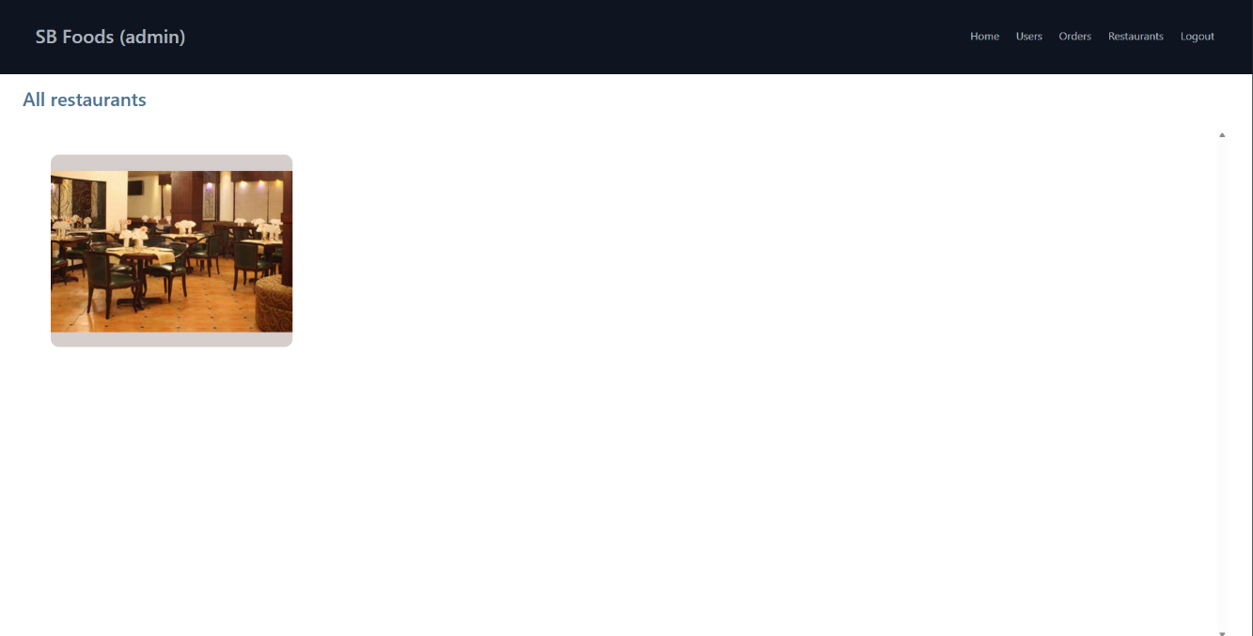
10. Testing
- Unit Testing: Jest for backend APIs.
- Integration Testing: Postman for end-to-end order flow.
- Manual Testing: UI navigation, cart operations, checkout.
11. Screenshots or Demo
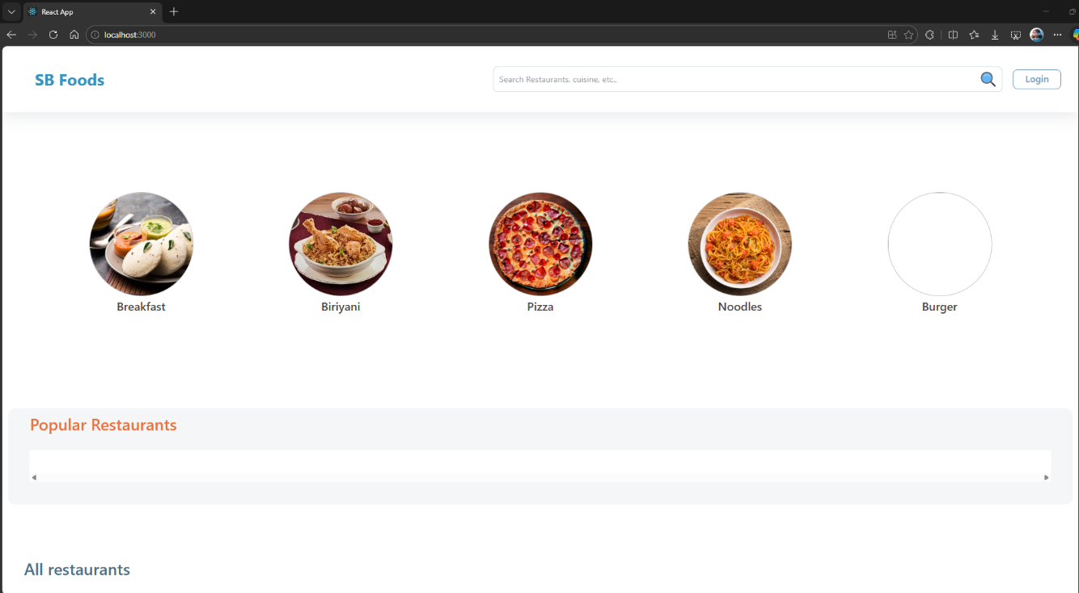

12. Known Issues
• Payment gateway sandbox mode may fail intermittently.
• Limited restaurant dashboard features (future scope).
• Notifications may require stable Firebase setup.

13. Future Enhancements
• AI-based personalized recommendations.
• Real-time delivery tracking with GPS.
• Mobile app version (React Native).
• Loyalty programs and discount coupons.
• Multi-language support for broader accessibility.

